November 30, 2024

Mr. Nanao Kachi

Director, Social and Consumer Policy

Canadian Radio-television and

Telecommunications Commission

1 Promenade du Portage

Gatineau, QC K1A 0N2

*Filed by GC Key*

Dear Mr. Kachi,

Re: Broadcasting Notice BRP 2019-308, English-language closed captioning mandatory quality standards relating to the accuracy rate for live television programming – Stingray Radio Inc. report for the broadcast year 2024.

1. Stingray Radio Inc. (“**Stingray**”) is pleased to file with the Canadian Radio-television and Telecommunications Commission (“**Commission**”) our BY024 report on quality standards and efforts to improve close captioning for CITL-DT and CKSA-DT Lloydminster, Alberta English-language services.

Stingray closed captioning report for the period September 1, 2023 - August 31, 2024

2. Stingray’s master control operators consistently monitor each programming feed to ensure captioning is present at all times. Consistent errors are reported in the daily fault reports and elevated to management.

3. Viewer concerns are logged for response and action as needed. We have not received any complaints regarding captioning in the last two years.

4. It is important to note that Stingray’s choice for closed captioning providers is limited due to the high cost of such services for smaller broadcasting operations. Consequently, in the event of inconsistent closed captioning services, we need to be able to count on our current provider, Apptek, who is currently the only provider that will fit in our cost structure. While we continuously push our provider for continued improvement of their services, including by continuously communicating any substandard activity in our monthly reporting, we unfortunately remain dependent on this third party to maintain quality closed captioning standards for our stations.

5. Although there are no in-house adjustments that can be made by Stingray’s team considering Stingray does not have the technical ability to do so, our Program Manager reached out to Apptek on numerous occasions during the reporting period requesting accuracy improvements and eliminations of words or phrases.

6. In addition, Stingray’s Chief Engineer is in direct communication with Apptek to work on obtaining further accuracy improvements and Stingray is hopeful this open dialogue will help towards solving existing issues in the services provided to us.

7. We continue to implement software updates that improve closed captioning accuracy.

8. NER reports and the associated video clips for BY 2024 are available at the link below

[BY2024 Closed Caption Reporting Stingray Radio Inc.](https://www.dropbox.com/scl/fo/bywrcl32u0k2gt8lzt0s1/h?rlkey=3j18bun52dtorxfo6ypgkbrw0&e=1&st=9pjvcgwf&dl=0)

As requested, all 2024 closed captioning report video files will be sent via Canada Post on a USB key.

9. Should the Commission have any questions regarding this report, please feel free to contact the undersigned.

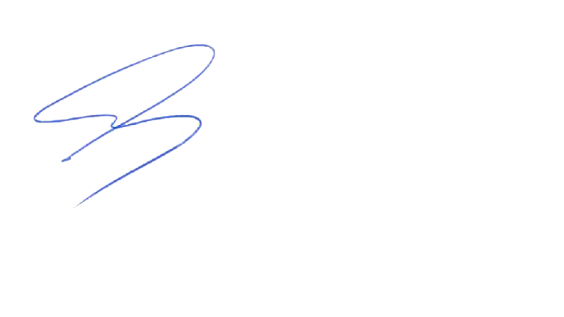

Yours truly,

Craig Letawsky

Director of Operations, Alberta

Stingray Radio Inc.

**** End of Document ****

Stingray Radio Inc.

#2000-2 St. Clair Ave West

Toronto, ON

M4V 1L5